GAD 10: Robotic Fish Enabled Pipeline Inspection

Background and Significance

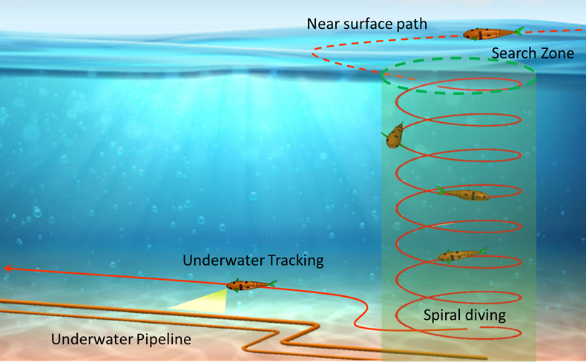
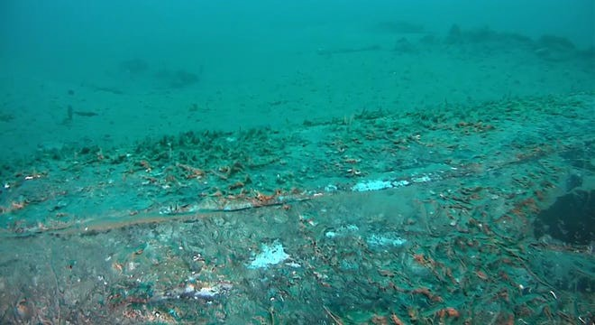
Oil pipelines have been deployed in the Gulf of Mexico for decades. After many years of service, the health conditions of those pipelines are unknown. Any leakage from pipes that carry harmful chemical fluids can cause significant pollution to the environment. For example, recently, a pipeline ruptured by a ship anchor, as shown in Fig. 1, in southern California leaks thousands of gallons of oil leakage which causes a despaired environmental disaster to the west coast. If the ruptures are not localized and repair in time, the harm to life, nature, and the economy can be dramatic. Timely inspection of subsea pipelines is thus the key to the prevention of environmental disaster caused by oil spills. Current inspection techniques often involve a trained human operator who operates a remotely controlled vehicle to take images and videos of underwater pipeline for offline rupture detection. Such inspection requires excessive amounts of time and money. With the introduction of state-of-the-art robotic and artificial intelligent technologies, such limitations can be remediated resulting in an extra layer of safety. The research objective of this project is to develop transformative engineering techniques and mathematical models that will lead to time-efficient and cost-effective intelligent robotic systems for underwater pipeline inspection. Such robotic systems will consist of a swarm of bio-inspired autonomous underwater vehicles (BAUVs) equipped with video cameras and underwater communication device with machine learning based image processing and edge computing capabilities. The BAUVs will be able to autonomously swim along a subsea pipeline, detect the ruptures of pipeline, intelligently interpret results through unsupervised machine learning and edge computing, and communicate with a nearby station through an underwater communication device. Through this robotic system, pipeline anomalies due to seismic activity, offshore drilling, turbulence, and ship anchoring may be detected at early stages allowing operators to make informed decisions on maintenance and repairs of the pipeline.
Figure 2: Envisioned BAUV enabled pipeline inspection.
Figure 1: Still image of ruptured pipeline caused by ship anchoring.

Accomplished Tasks and Results:
Task 1: Bio-inspired Robotic Fish Development
In this task, we completed the design and fabrication of the robotic fish and conducted initial water tests using a harness. These tests helped refine our circuitry and allowed us to assess the current requirements for the tail steering servo motor and the tail mechanism motor. We also successfully tested the linear actuator for buoyancy control and implemented depth control using a standalone depth control device. Significant progress was made in circuitry design and fabrication, enabling harness-free operation of the 3D Robotic Fish. This included wiring both inside the watertight enclosure and external components using waterproof, IP68-rated components. Harness-free swimming tests were conducted using a handheld radio controller and receiver, with the receiver installed inside the fish. These tests, powered by batteries, achieved a good swimming speed. However, conclusive results are pending improved circuitry and transmitter-receiver connections.
Our focus in this task was on analyzing and selecting the best scheme for camera integration for pipeline tracking. This involves careful consideration of an over-the-shelf camera for integration.
We dedicated significant efforts to seamlessly integrating a sophisticated camera system into the fish's structure. This achievement significantly elevates our underwater surveillance capabilities and opens new possibilities for data collection and aquatic exploration.

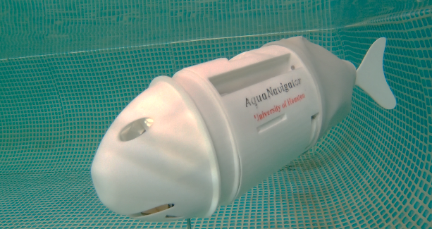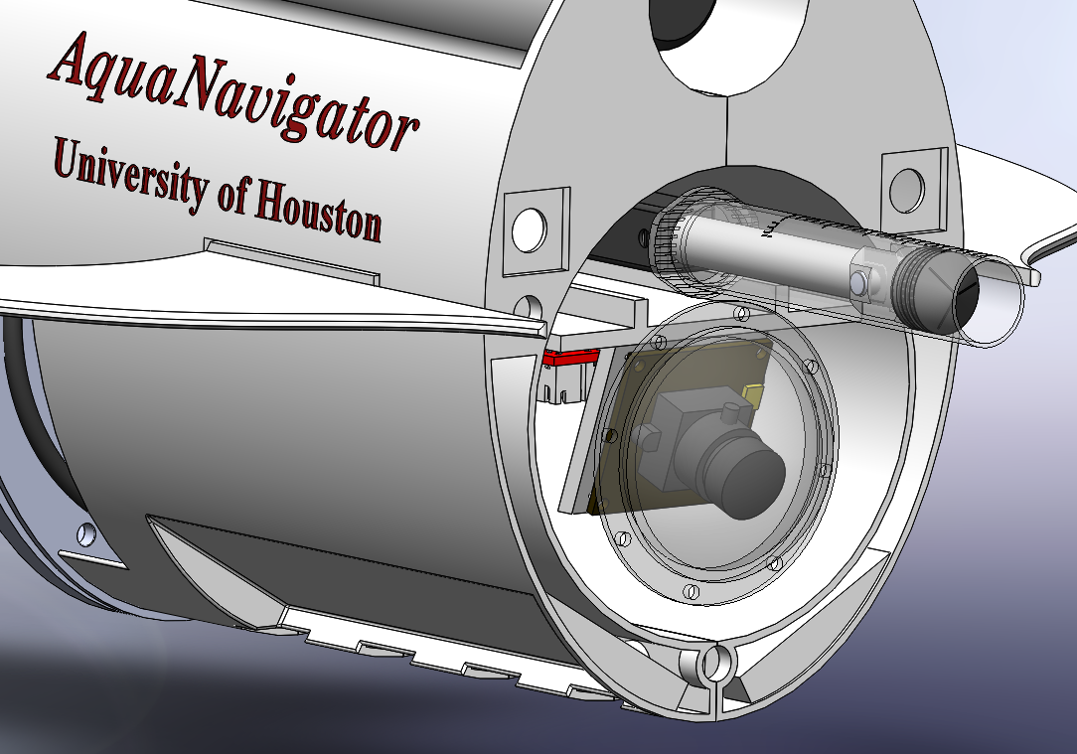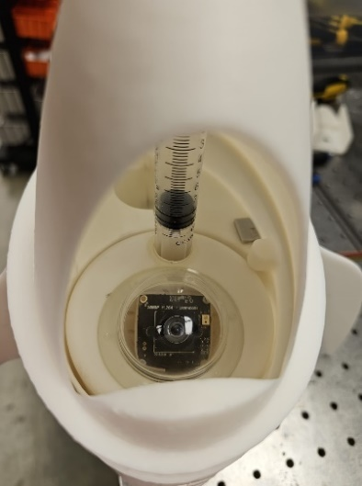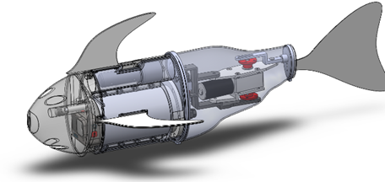
Figure. 3. Robotic fish design and fabrication results.

A major accomplishment in this task was the meticulous fabrication of the robotic fish, emphasizing attention to detail and precision. A standout achievement was the successful integration of the camera system into the robotic fish's operations, allowing the fish to transmit live camera feeds to the host computer. While some wiring tasks remain, this accomplishment is a significant stride toward realizing our project's goals, promising applications in marine research, environmental monitoring, and security. The wiring inside the water tight enclosure and outside where water-proof IP68 rated components are used, is completed. With this a harness free, swimming can be tested. Harness free movement of the fish with its own propulsion power was tested with a handheld radio controller and receiver. The receiver was installed inside the fish. Everything was battery powered for this testing so that the free swimming can be assessed. Considerably good swimming speed was achieved, but this test couldn’t not conclude any measurable results for now. This test has been done again with improved circuitry and connection between the transmitter and receiver.

Task 2: Pipeline tracking control integration with Bio-inspired robotic fish
In this task, we developed a robust image-based visual servoing (IBVS) control which is based on the difference between desired and current features on the image captured by the onboard camera. This IBVS approach does not require much knowledge about the 3D environment and demands less computation. The objective of the control law is to steer the robotic fish along the predetermined pipeline de- tected by computer vision in Task 2.3. The control law introduced a path following behavior for autonomous characters in programs and games by changing the direction of velocity. A prediction vector is made to estimate the character’s future position as shown in Fig. 5. We have successfully reassembled the ROV, replaced its entire electronic enclosure, and meticulously inspected every interface to guarantee its full waterproofing. Currently, our pipeline tracking functions effectively on black pipelines that contrast with their surroundings. However, it faces challenges when the pipeline is white or if the water is murky. To address this, we're in the process of creating tensor-voting algorithms that will make the pipeline tracking more versatile, allowing it to function in varied conditions including on partially buried pipelines or in murky waters.

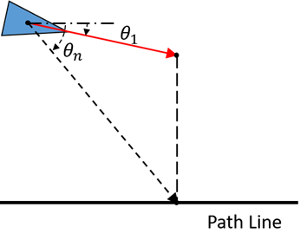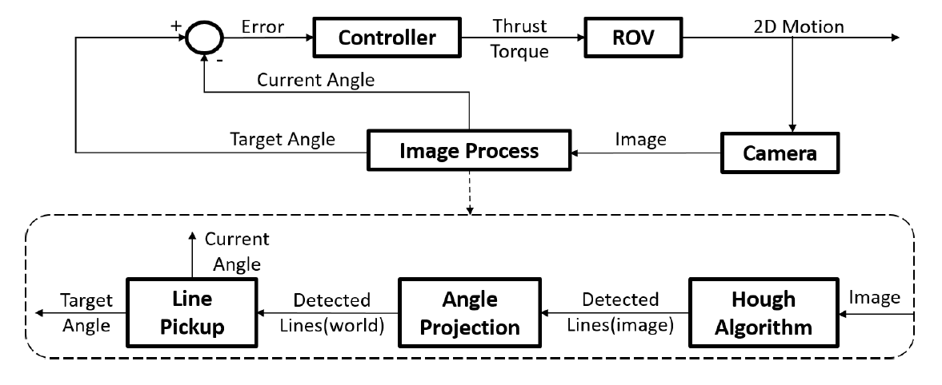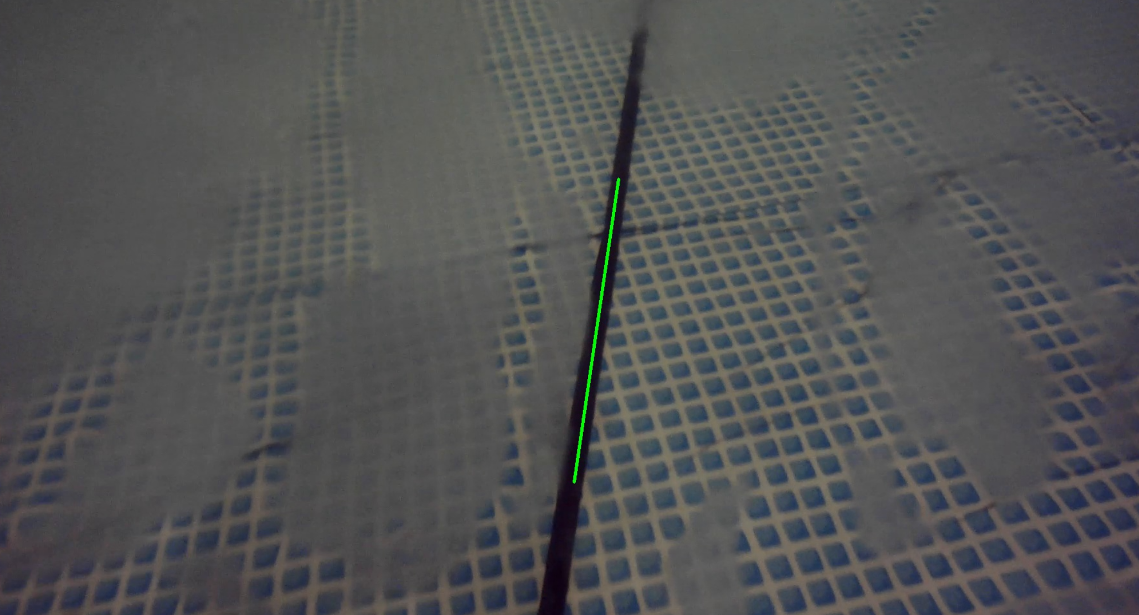
Figure 4. ROV pipeline tracking results.
Task 3: Develop deep machine learning and vision-based pipeline detection
In this task, we developed an energy saving and safe multi-agent reinforcement learning framework. Multi-agent reinforcement learning is solved using a transformer, which is a sequence model that has great generalization capabilities. We use offline reinforcement learning to leverage offline datasets to learn optimal policy without the necessary to access the real underwater environment. The following graph shows that our method outperforms some state-of-the-art methods on benchmark data. We finished the development of deep learning and vision based underwater image enhancement. A DeblurGan was used to remove motion blur from the image. A color enhancement deep neural network was used to correct the color distortion of the underwater image as shown in the above figure.
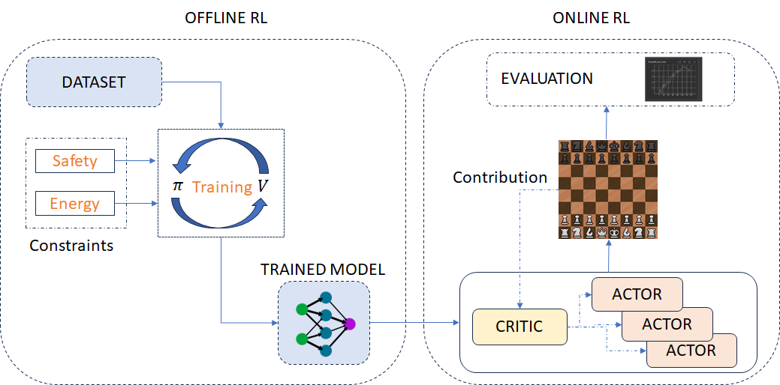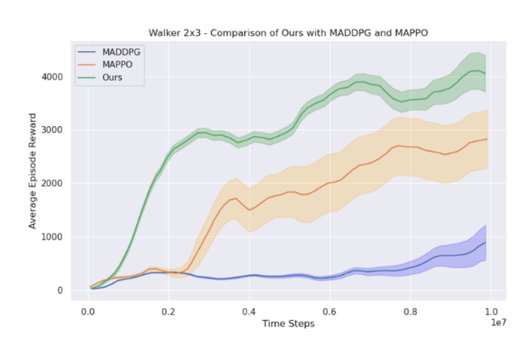
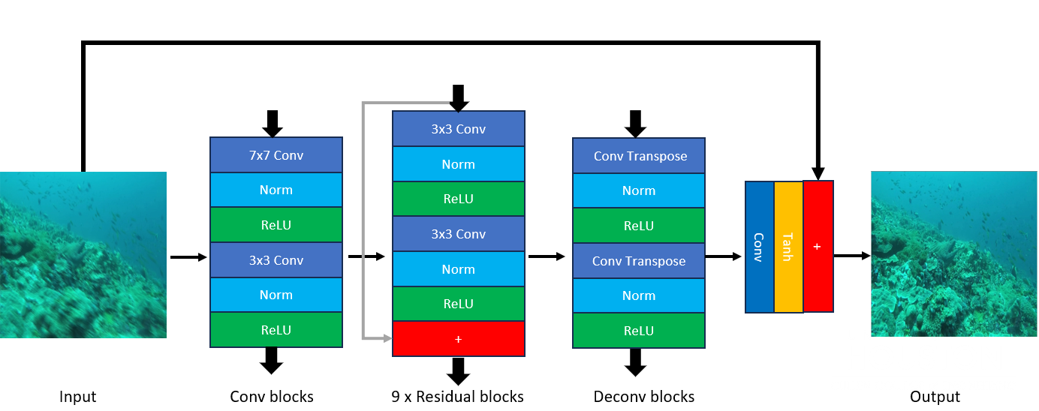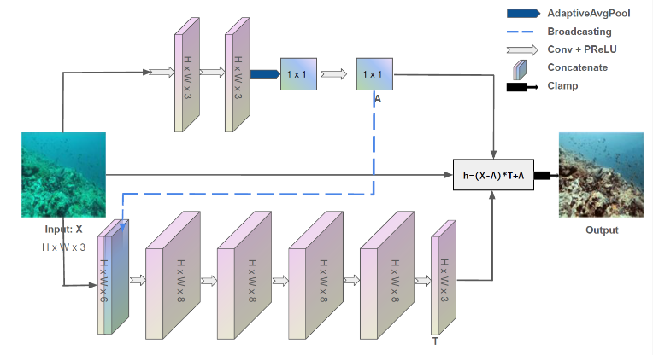

Figure 5. Machine learning based color enhancement results.

Task 4: Develop edge computing for limited bandwidth data transmission
In this task, we set up a Raspberry Pi platform for testing edge computing algorithm. We formatted the platform and installed dependencies so that it can run machine learning programs and record from the camera properly. We added a remote connection via IP address so that the Pi can be controlled without the need for a wired connection. We tested on a pre-trained model to determine if the Pi can run an object detection model. We programed the camera with Python so that it can detect objects and highlight them with a bounding box. We gathered and labelled dataset with LabelImg. We trained the dataset and deploy trained model to the Tensorflow Lite platform and tested it on a mobile car that carries the Raspberry Pi. We were able to get Tensorflow Lite to work on the Raspberry Pi and camera (Fig. 6). We downloaded a pre-trained model provided by Colab’s official site, which had around 80 objects within its dataset. The resulting stream varied from 1.8 to 2 frames per second. It highlighted the detected object in real time with its confidence percentage shown on the corner (Fig. 6). The following pictures shows Raspberry Pi and camera setup (port setup: micro-USB = power supply, HDMI = monitor, USBs = mouse & keyboard) and the object detected using our deep neural network model running on the Raspberry Pi. In addition to getting a pre-trained object detection model to work, we were also able to remotely access the Raspberry Pi by installing VNC software and connecting the Pi’s IP address to a computer. This will allow for convenient coding and information sharing.
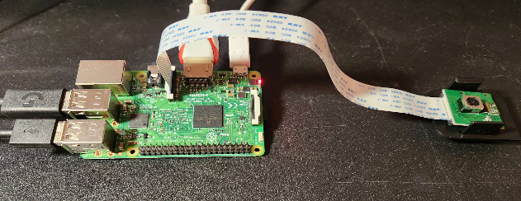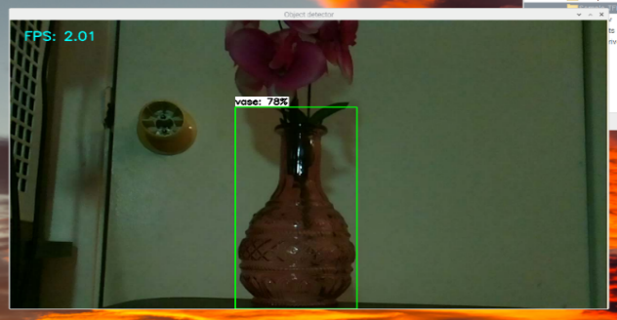
Figure 6. Platform for edge computing and results of detecting an object.
Task 5: Comprehensive Testing
The machine learning based image enhancement was integrated into the robotic fish pipeline tracking software, and tests were conducted. The test results led us to improving image enhancement performance through more data in learning process. The performance as of now is shown in the Figure. 7.
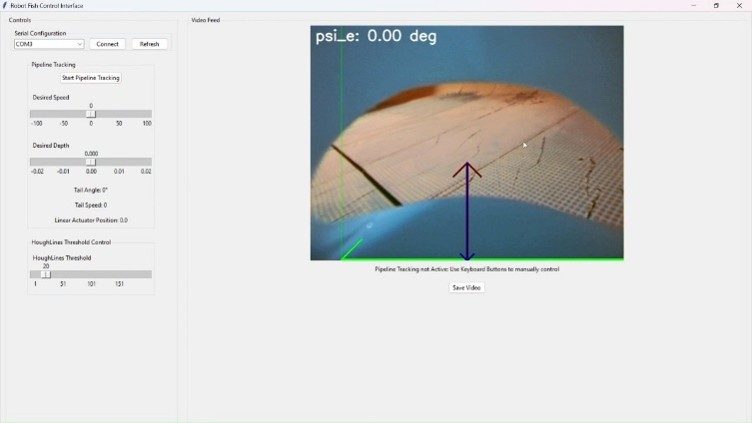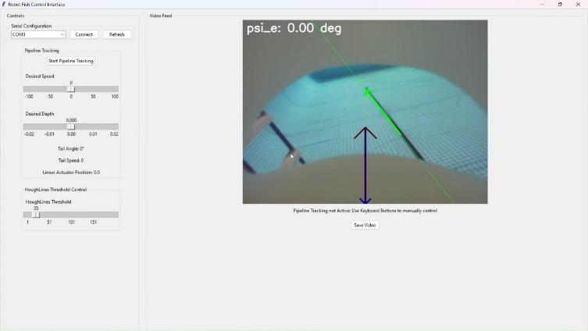
With Image Enhancement
Without Image Enhancement
Figure 7. Pipeline tracking results with and without machine learning based color enhancement.

Pipeline tracking has been tested with different scenarios and the performance has been validated with multiple engineering parameters. The feedback of the pipeline tracking is assessed through the camera image and a performance parameter called $ψ_{e}$ holds the effect of both the distance from the pipeline and the orientation of the robotic fish with respect to the pipeline. Some of the results are shown in the figures below, evidently suggesting that the pipeline robotic fish converges to the pipeline track in considerably good response time. $y$ having the units of pixels, is another parameter primarily showing the distance between the pipeline and the robotic fish. For better understanding of the tracking in non-technical perspective, a rooftop camera was used to see the physical robotic fish converging to the pipeline when the start point was away from the pipeline but still the pipeline was within the viewing angle of the on-board camera.
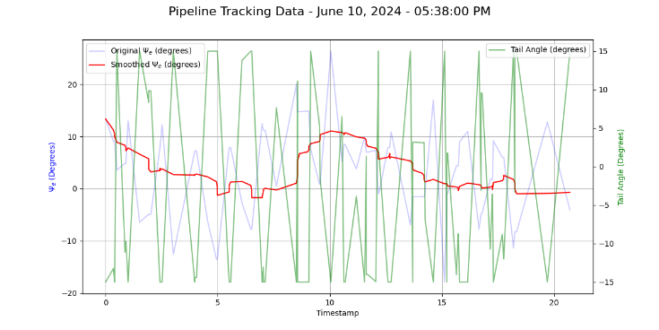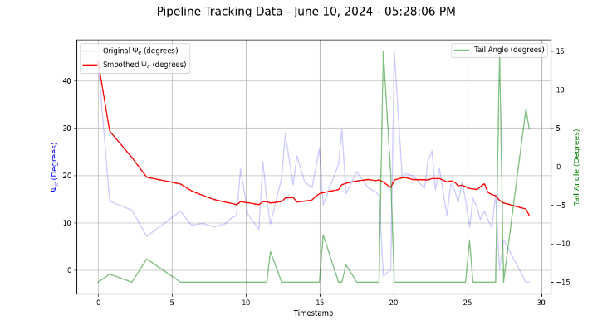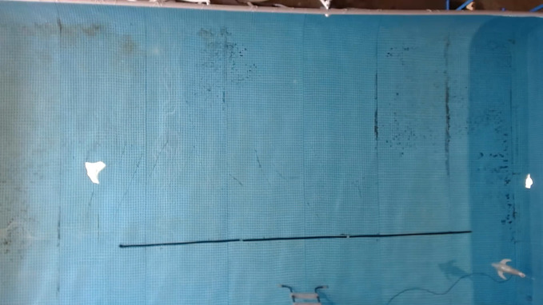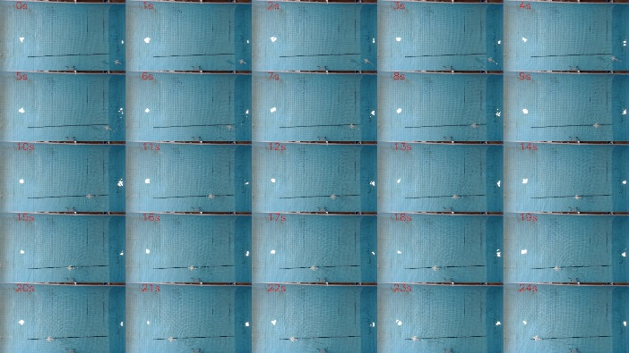
Figure 8. Comprehensive testing results: robotic fished enabled pipeline tracking.

Students and Postdoc
This SSI grant has supported four PhD students: Umar Masood, Qiang Zhu, Denizcan Koc and Mai Nu Ngoc Lei, and one summer intern researcher: Gonzalez, Salvador A.
- Umar Masood, PhD Student
Umar Masood is a PhD student in the Bio-inspired Robotics and Controls lab, under supervision of Dr. Zheng Chen. Umar joined this project since it started in Feb 2023. His work was focused on depth control device, robotic fish design, fabrication, and testing, pipeline tracking control design and implementation on robotic fish.
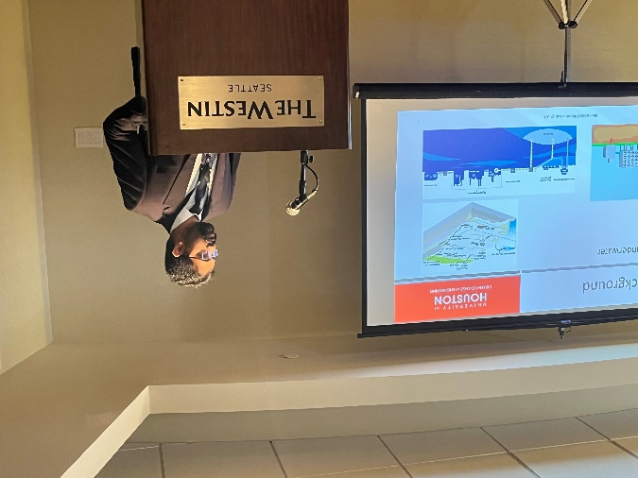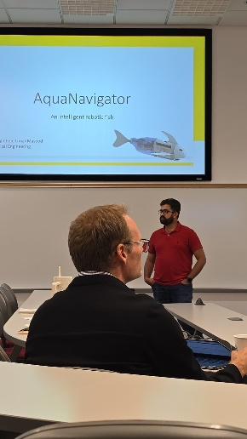
Figure 9. Umar Masood presented his depth control work at AIM 2023 (left), Energy Transition Innovation Competition 2024 (right).
- Qiang Zhu, PhD Student
Qiang Zhu is a PhD student in the Bio-inspired Robotics and Controls lab, under supervision of Dr. Zheng Chen. Qiang joined this project in January 2023. His work was focused on image processing, Hough algorithm, pipeline detection and tracking control. Qiang followed Dr. Chen’s former PhD student Xiongfeng Yi’s work and validated the tracking control on a BlueROV.
- Denizcan Koc, PhD Student
Denizcan Koc is a PhD student in the Bio-inspired Robotics and Controls lab, under supervision of Dr. Zheng Chen. His work was focused on buoyancy control of robotic fish.
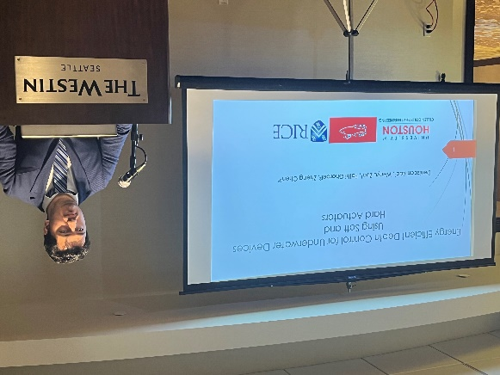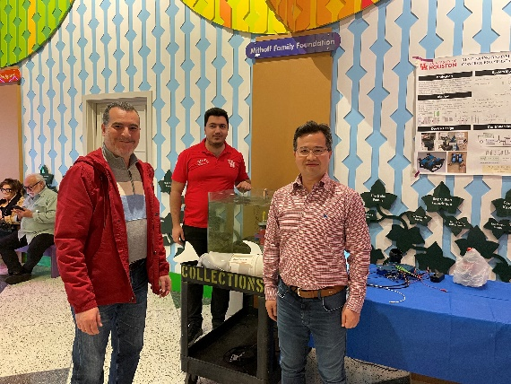
Figure 10. Denizcan presented buoyancy control at the IEEE International Advanced Intelligent Mechatronics Conference (left) and the Children’s Museum in Houston in 2024 (right).
- Le, Mai Nu Ngoc, PhD Student
Mai Nu Ngoc Lei is a PhD student Electrical and Computer Engineering, under the supervision of Dr. Jiefu Chen. Mai joined this project in January 2023. His work was focused on edge computing platform design and testing.
- Gonzalez, Salvador A, Undergraduate Student/Summer Intern
Salvador Gonzalez is a summer intern in the Bio-inspired Robotics and Control lab, under the supervision of Dr. Zheng Chen. Salvador was a domestic Hispanic undergraduate student in Mechanical Engineering at UH. Salvador joined this SSI project as a volunteer in Spring 2024. His effort for this SSI project was focused on some outreach activities. His current work as summer intern is focused on optimization of robotic fish tail. Salvador will pursue his MS degree in Mechanical Engineering at UH in Dr. Chen’s lab.
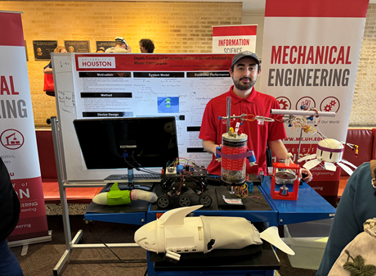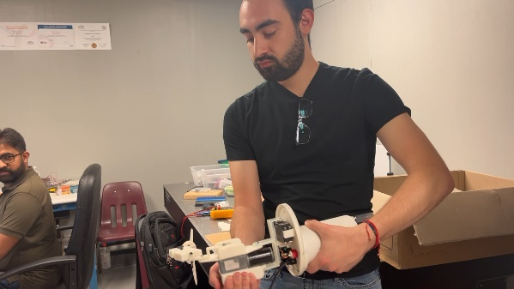
Figure 11. Salvador presented robotic fish at the Welcome Reception for Admitted Undergraduate Engineering Students (left), and tested a new robotic fish tail in Dr. Chen’s lab (right).

