SC Voucher Creation
PeopleSoft 9.1

Presented by General Accounting

Table of Contents

1. Creating a Local SC Voucher Page 2
Invoice Information Screen Page 3

2. Creating a State SC Voucher Page 7
Invoice Information Screen Page 8

3. Summary Screen Page 12

4. Documents Screen Page 13

5. Approval Screen Page 15

6. SC Voucher Notification Page 16

7. Resources Page 18

Creating a Local SC Voucher

To create a Local SC Voucher from the Menu select:
- Accounts Payable
- Vouchers
- Add/Update
- Regular Entry
- At the voucher entry screen
  - Select Add a New Value tab
  - Enter Business Unit SC730 or SC783
  - Select SC Vendor by ID or Name
  - Invoice Number
  - Invoice Date
  - Gross Invoice Amount = 0.00
  - Estimated No. of Invoice Lines (Minimum of 2 lines)
- Select the ADD button

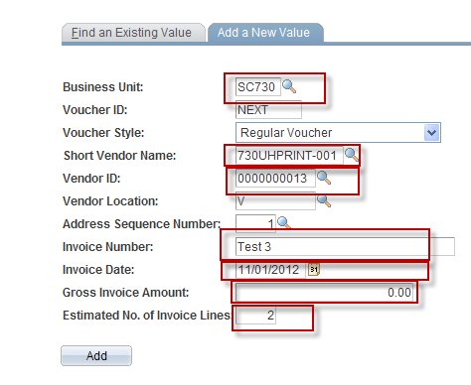

Invoice Information Screen – Local SC Voucher

Debit and credit voucher accounting lines are recorded when creating a local SC Voucher. A debit is recorded to the cost center of the department purchasing services from the Service Center and a credit is recorded to the Service Center’s cost center which is listed in the vendor address.

On the Invoice Information Screen:
- Select the Comments link to enter the description of goods/services purchased and the purpose and benefit
- Select the Calc Basis Date and enter
  - Invoice Receipt Date
  - Invoice Date
  - Good Receipts Date
  - Acceptance Date

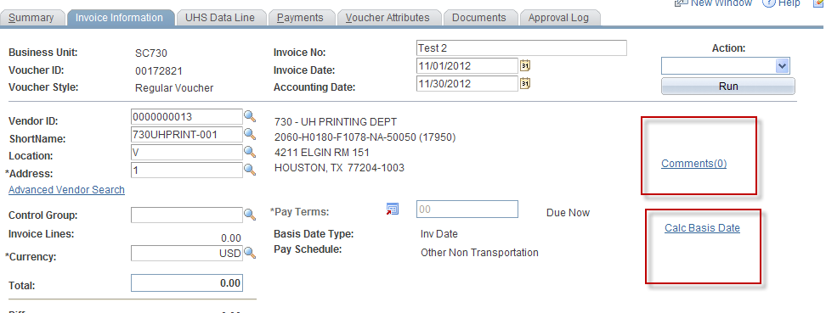
Invoice Information Screen – Local SC Voucher (continued)

For each voucher accounting line:
- Enter the speed type in the SpeedChart field or cost center and account of the department purchasing services from the Service Center. (Debit)
- Enter the speed type in the SpeedChart field or cost center and account listed on vendor’s address for the SC Vendor. (Credit)
- Enter the Line Amount and Description on the Invoice Line

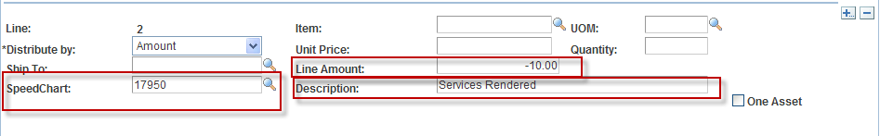

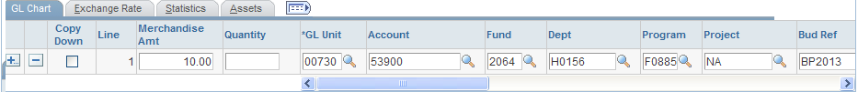
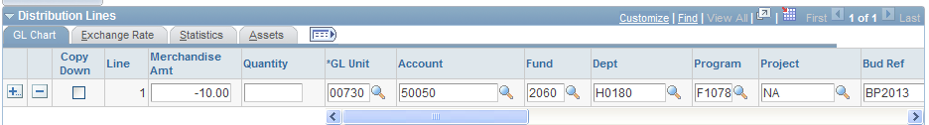

Invoice Information Screen – Local SC Voucher (continued)

- Verify the sum of all debits and credits equal zero in the Total field
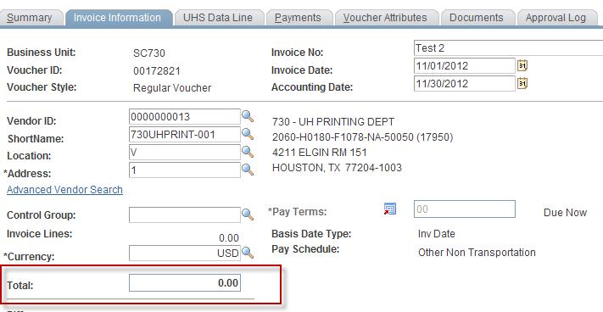

- Save Voucher
- Select Budget Checking in the Action Box
- Run Budget Checking Action

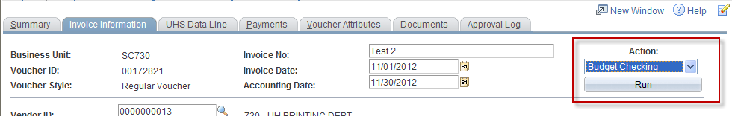

Invoice Information Screen – Local SC Voucher (continued)

You will receive the following message to select either Yes or No

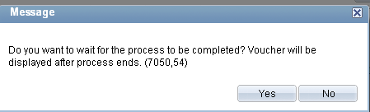

After budget check has run the Budget Status will appear on the Summary Tab

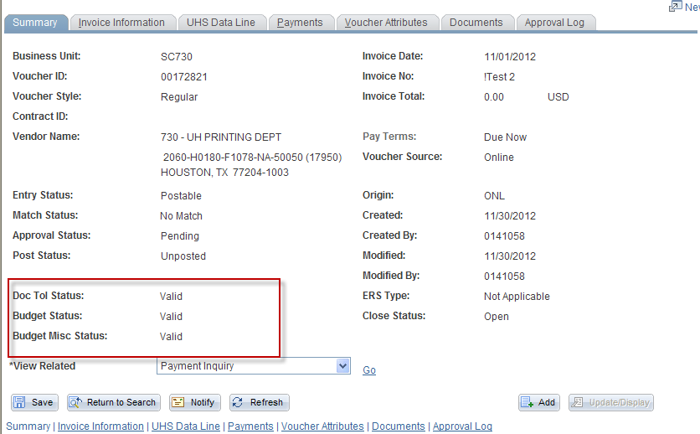

Creating a State SC Voucher

To create a State SC Voucher from the Menu select:
- Accounts Payable
- Vouchers
- Add/Update
- Regular Entry
- At the voucher entry screen
  - Select Add a New Value tab
  - Enter Business Unit SC730 or SC783
  - Select SC Vendor by ID or Name
  - Invoice Number
  - Invoice Date
  - Gross Invoice Amount = Invoice Amount
  - Estimated No. of Invoice Lines (Minimum of 1)
- Select the ADD button

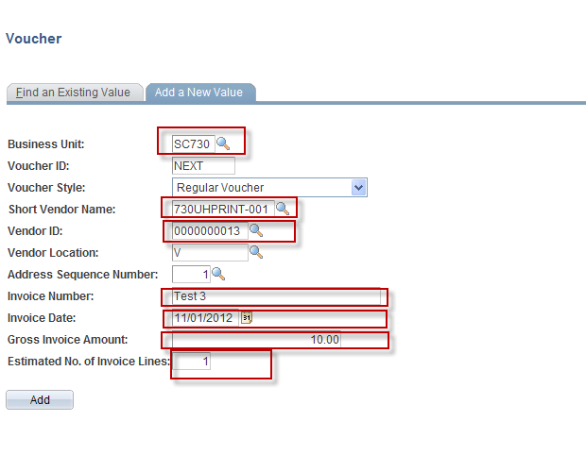

Invoice Information Screen – State SC Voucher

When payments are made to Service Center with State funds, a debit is recorded to the cost center of the department purchasing services from the Service Center. An offsetting credit line is not entered.

- Select the Comments link to enter the description of goods/services purchased and the purpose and benefit
- Select the Calc Basis Date and enter:
  - Invoice Receipt Date
  - Invoice Date
  - Good Receipts Date
  - Acceptance Date

Invoice Information Screen – State SC Voucher (continued)

For each voucher accounting line:
- Enter the speedtype in the SpeedChart field or cost center and account of the department purchasing services from the Service Center. (Debit)
- Enter the Line Amount and Description on the Invoice Line

- Verify the amount in the Total field equals the invoice amount
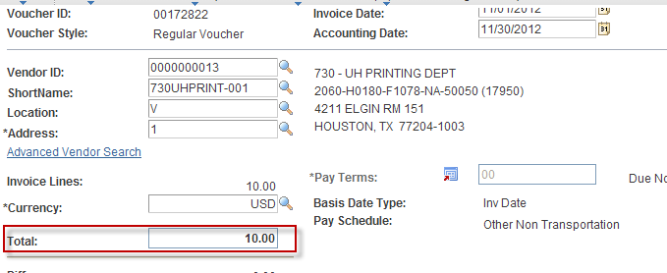

Invoice Information Screen – State SC Voucher (continued)

- Go to Payments Tab to change the Bank field to State (The State bank must be used when state cost centers are used.)

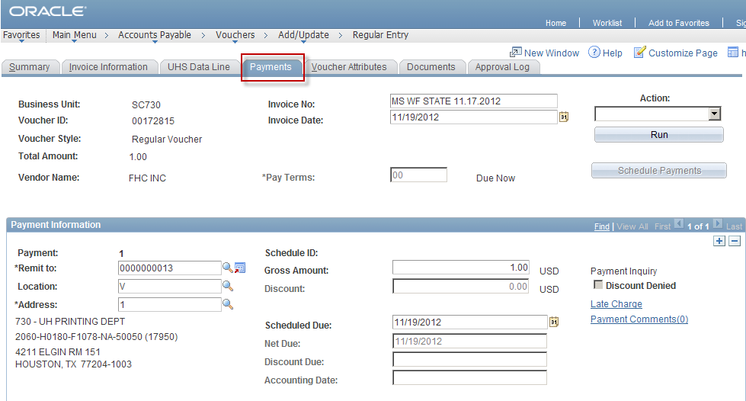
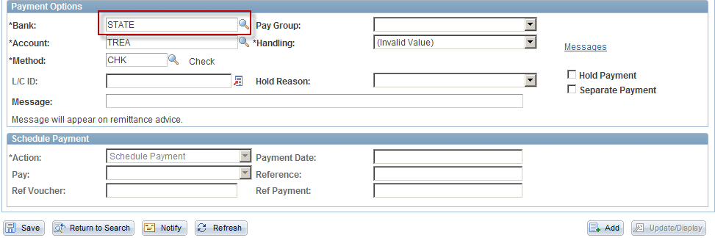

- Save the voucher

Invoice Information Screen – State SC Voucher (continued)

- Return to the Invoice Information Tab, select Budget Checking in the Action box
- Run Budget Checking Action

You will receive the following message to select either Yes or No

Summary Screen

After the budget check has run, the Budget Status will appear on the Summary tab

Documents Screen

To attach back-up to support the SC Voucher:

- Select the Documents tab
- Select the Add New Document button

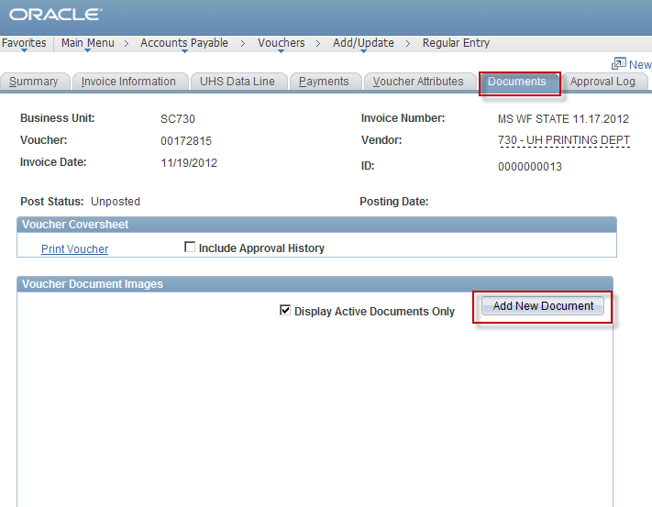

Documents Screen (continued)

The Document Upload page will appear
- Select the Browse button
- Select document from file

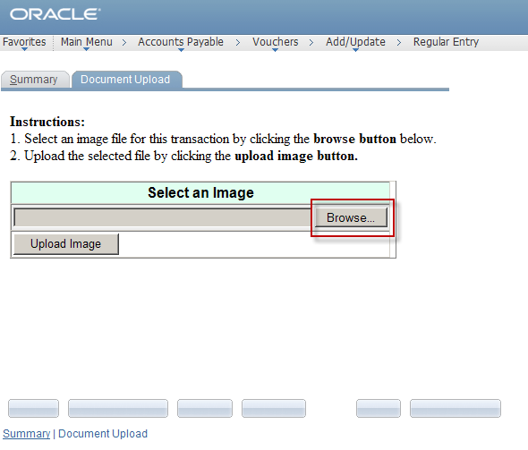

Examples of backup documents:
- Order form completed by the department
- Quote or invoice from the service center

NOTE: SC Vouchers are not required to include backup documents, as long as the voucher comments adequately describe what is purchased. The SC Voucher itself may serve as the order form and/or invoice.
Approval Screen

After attaching backup:
- Go to Approval tab
- Select the approval path
- Select approval action
- Select Apply button

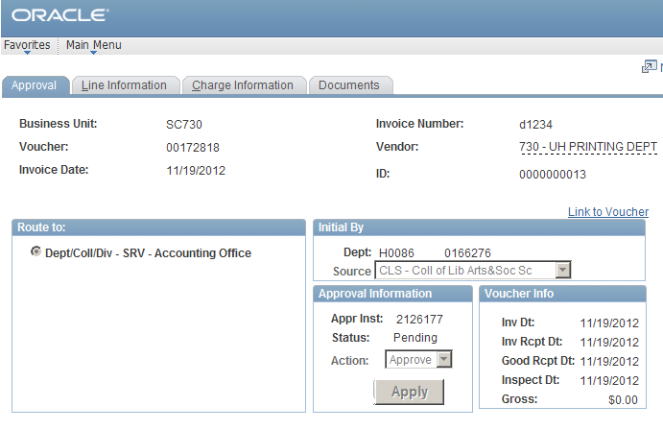

This will submit the SC voucher to workflow for approval.

As each approver (Department, Intermediate, and Final) approves the voucher approval history displays the time, date, and name of every user that applied an approval action to the Voucher.

The Comment history also shows all approval actions for the voucher.

If any information on an SC voucher is not correct, it will be denied and sent back to the creator’s worklist.

SC Voucher Notification

The Notify button allows users to send an email message with an attached link to another user regarding a SC Voucher.

To send an email using the Notify button select the following:

- Notify button
- Lookup Recipient link
- Search button
- Chose recipient from search results
- Add to Recipient List button
- OK button
- Complete email notification message
- Select the OK button

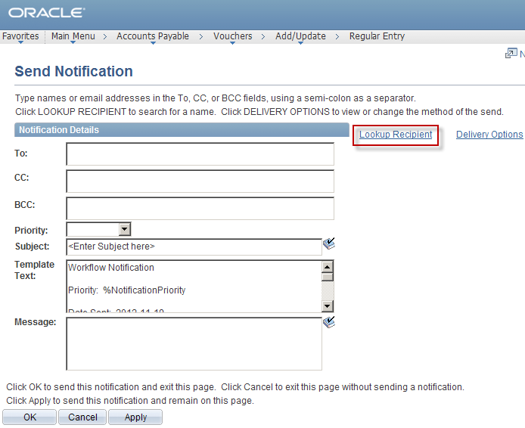

SC Voucher Notification (Continued)

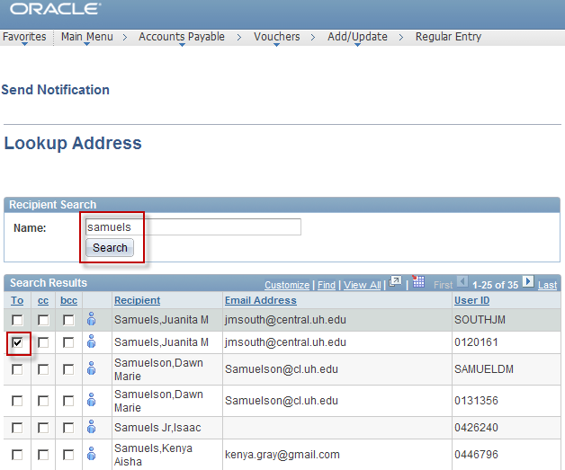

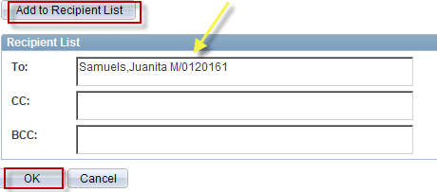

Resources

General Accounting Email

genacctg@Central.UH.EDU

Website: www.uh.edu/finance

