Instructions for Creating a Query Favorites List
If you have a handful of queries that you run often, and you have the ability to create your own private queries (Query Manager), you can create a favorites list in PeopleSoft for easy access to those queries.
The following steps will guide you through the process of creating a list of favorite queries in PeopleSoft:
Step 1
Navigate to Query Manager and enter search criteria to retrieve the desired query. Click Search.
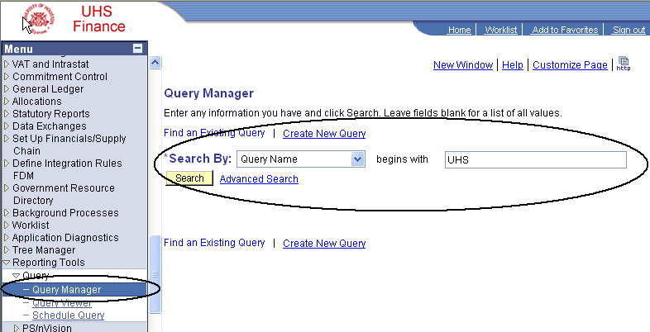

Step 2
Select the query that you wish to add to your favorites list. Use the drop-down Action window to select the Add to Favorites action. Click Go.
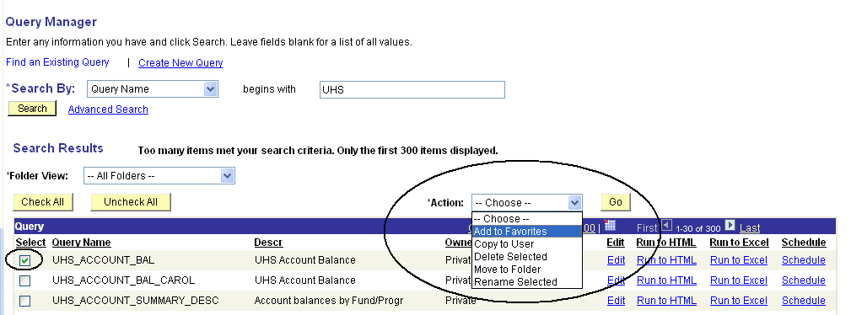

Step 3
A My Favorite Queries heading has been added to the page and the query displayed in the list. If at any point you would like to remove a query from the list, click the Remove button located to the far right of each query listing. Finally, if you would like to clear the entire list, click the Clear Favorites List button at the bottom of the favorites list.

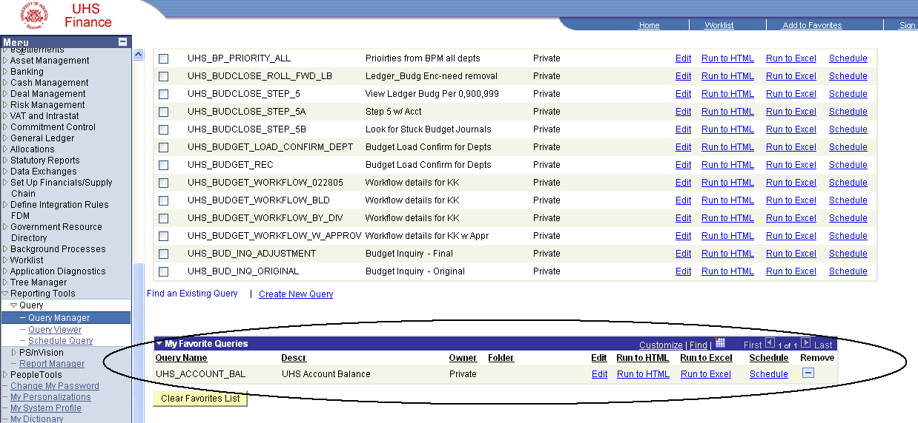

Step 4
Close the query window and open it again. The My Favorites Queries list now appears automatically.

