How to delete a voucher
Step 1: Go to Accounts Payable>Vouchers>Add/Update>Delete Voucher
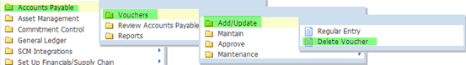

Step 2: Enter the voucher number and click on .
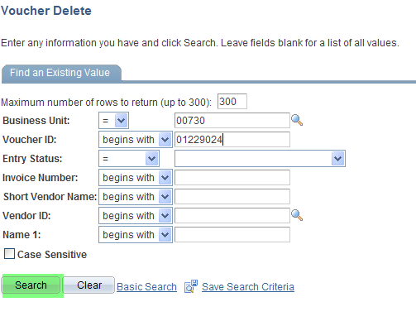
Step 3: The system displays the following screen. Click on .
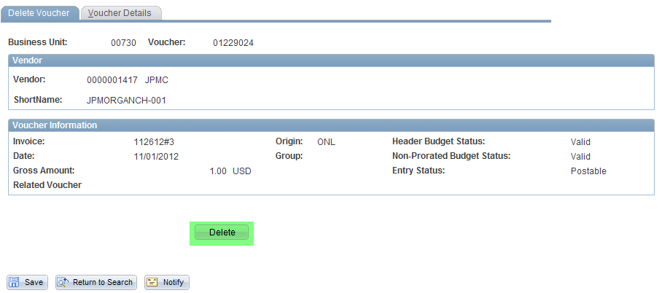
Step 4: The system displays the following message. Click on .
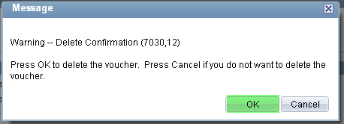

Step 5: The system displays the following message. Click on .
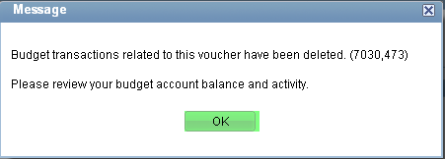

Voucher is now deleted. The system automatically re-budget check after a voucher is deleted.

