How to create and submit a PO voucher

Step 1: Go to the finance system log on page and log on.
You can go to the finance website http://www.uh.edu/finance and click on Financial System Log on.

Enter your User ID and Password, and then click on Sign In.
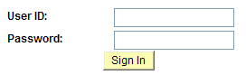
You can also go to the UH home page http://www.uh.edu/ and click on “Login to AccessUH” to sign in.
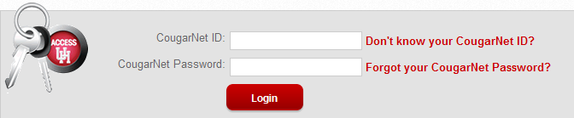
Step 2: On the main menu, bring the cursor to Accounts Payable, Vouchers, Add/Update, and then click on Regular Entry.

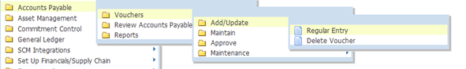
Step 3: The voucher Add a New Value page is displayed. Click on .
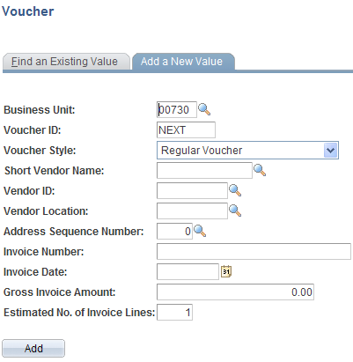
Step 4: In the Invoice Information page, enter PO unit and PO number. Then, click on .
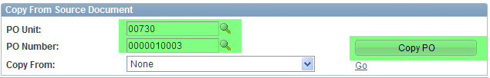
Step 5: The system automatically copies the PO information (Vendor, PO Lines, Cost centers, etc.) to the voucher page.
Step 6: You should make sure that the following information are entered at this time:

Vendor ID
Vendor Name
Vendor Location
Vendor Address
Invoice No
Voucher Total
Voucher Line Amount
Merchandise Amount
Account
Cost Center

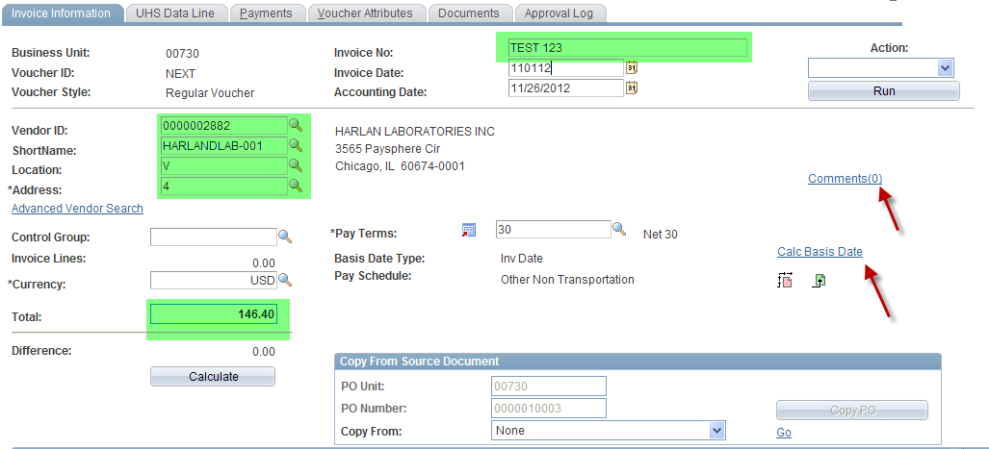
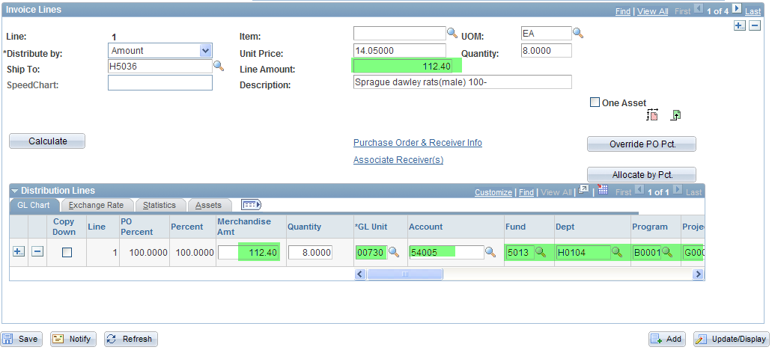

Step 7: Click on “Calc Basis Date” (see the red arrow indicated in Step 4) in the invoice information page and enter the four dates that are required to calculate the payment basis date. Click on the Calculate button below, and then click on “Back to Invoice” to go back to the invoice information page.
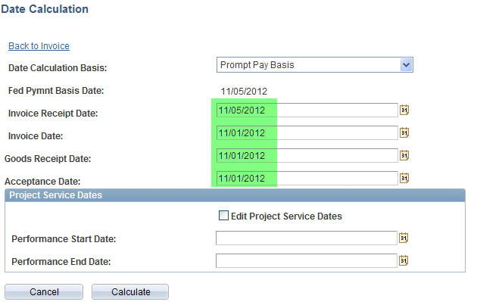

Step 8: Click on “Comment” in the invoice information page (see the red arrow indicated in Step 4) and enter the purpose/benefit for the expenditure. Then click on OK.

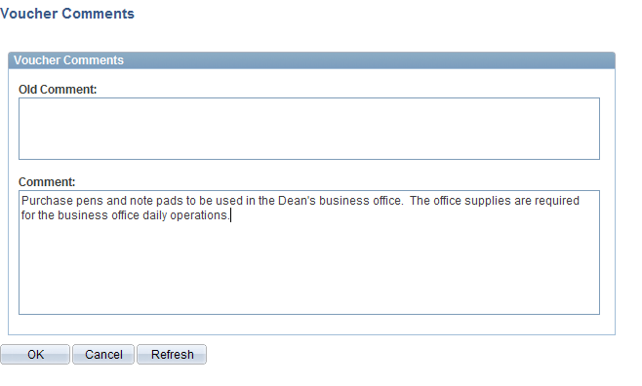
Step 9: Go to the Document page and upload the backup document (same as PS8.4).
Step 10:The invoice information page is displayed again. Click on the Save button to save the voucher. The system assigns the voucher ID.

Note that the system now displays the summary tab.

Step 11: In the invoice information page, go to “Action” (upper right corner) and select “Budget Checking” from the drop down box. Then click on the Run button.

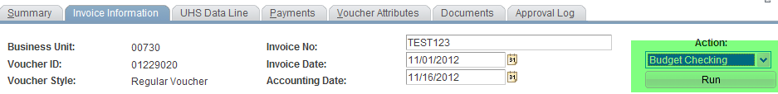

When the system asks if you want to wait for the budget checking process to be completed, click on Yes.

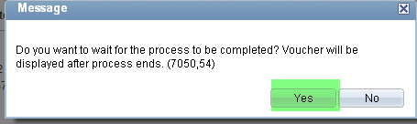

Step 12: During the budget checking process, the processing icon  is displayed. Once it is completed, you will no longer see the icon. Go to the summary page to see the budget checking status.

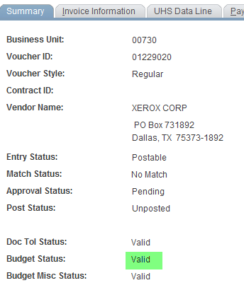

Step 13: Submit the voucher into workflow (same as PS8.4)

