PROCEDURE TO CREATE A BUDGET JOURNAL

STEPS:

- Click Main Menu > Commitment Control > Budget Journals > Enter Budget Journals.

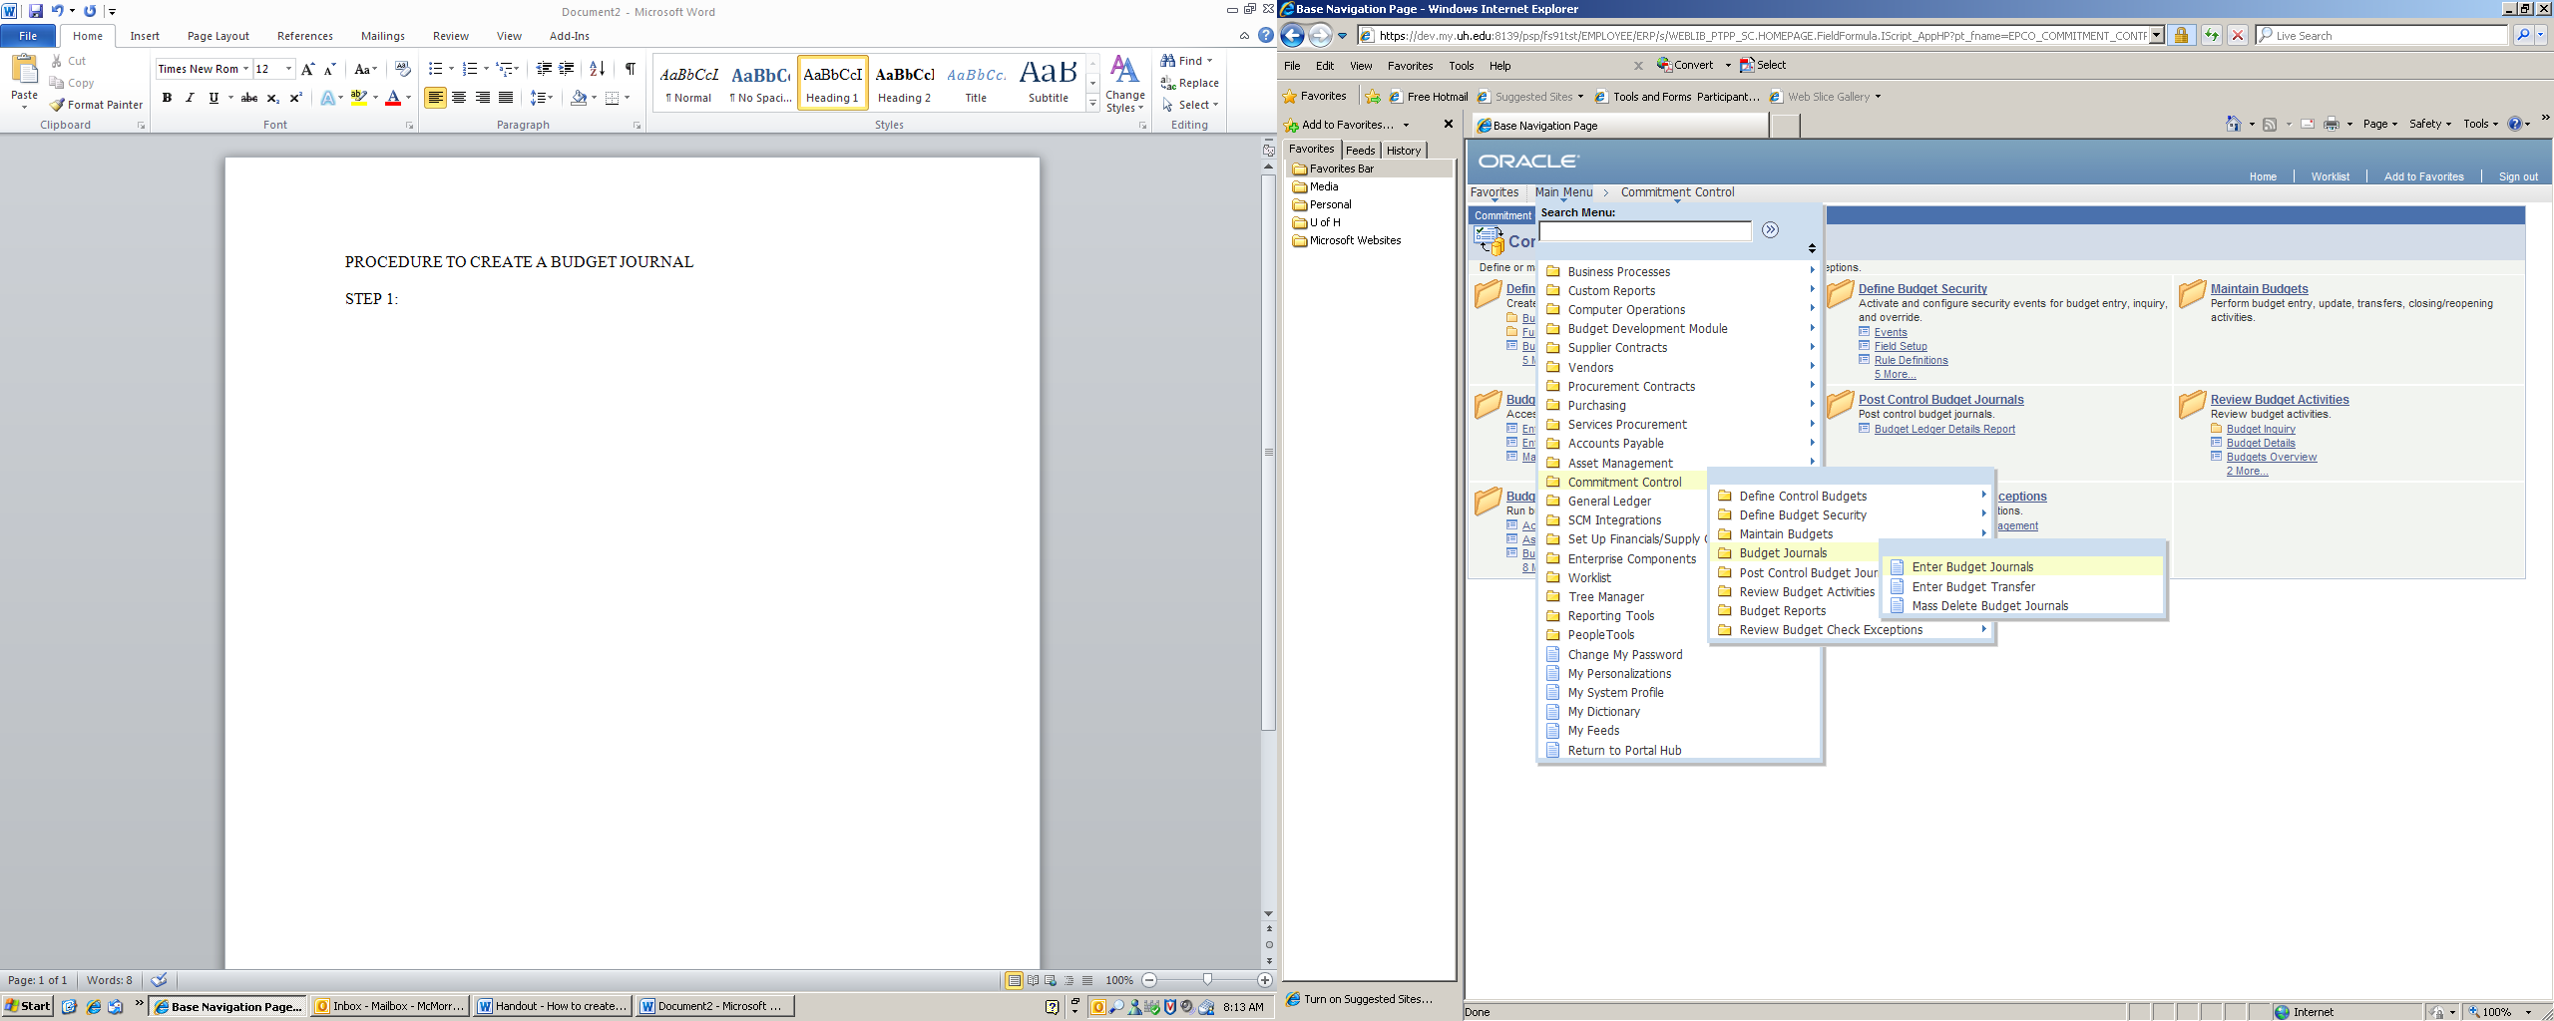

- Change “Business Unit” and “Date” if applicable. “Add”.
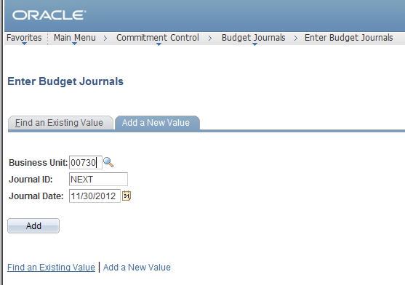

- Select “Ledger Group” from the Look Up Ledger Group

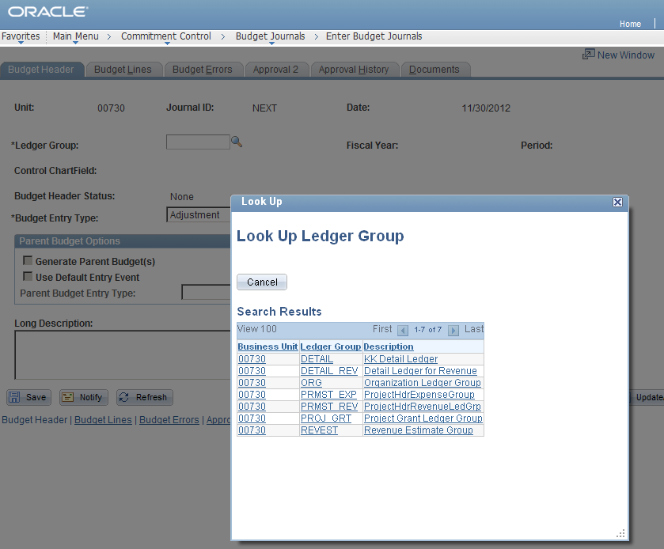

- Select Budget Entry Type from the drop down menu

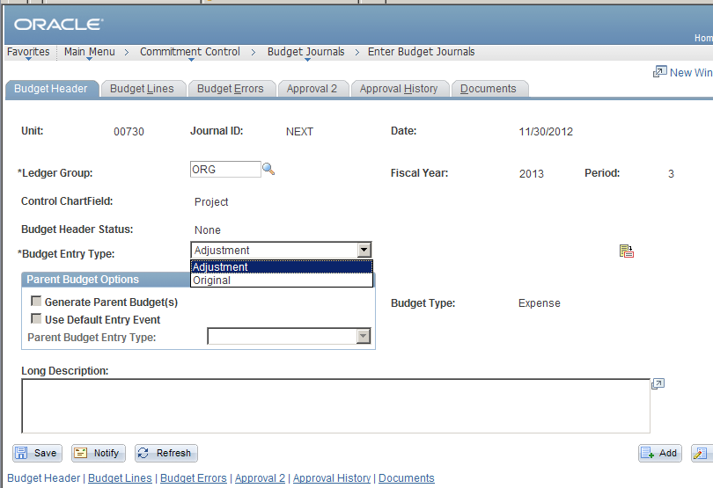

- Enter the “Long Description” stating the purpose of the budget journal. The description below is for a new temporary faculty position that will be funded for current year only and budget is being transferred from M&O budget.

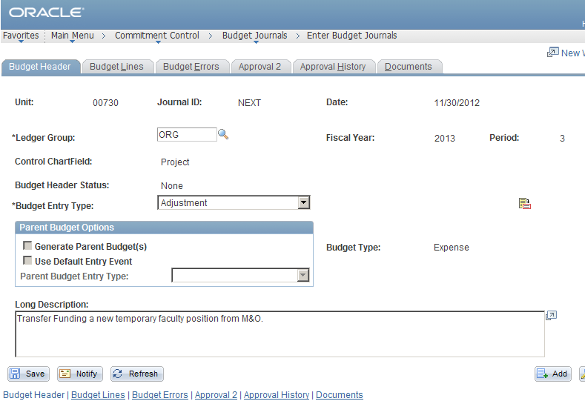

- On the “Budget Lines” tab, enter either the Speed Type or cost center combo”, “Budget Node” and the amount.
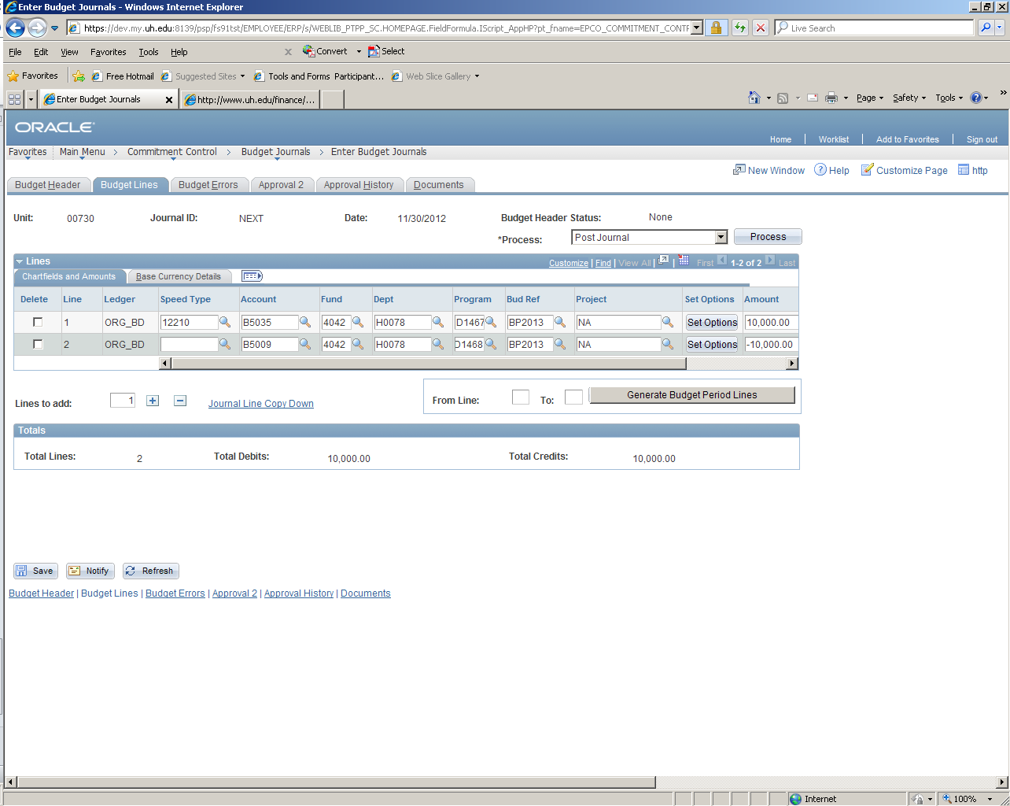

- Process – Budget Pre-Check first and then select “Process” button
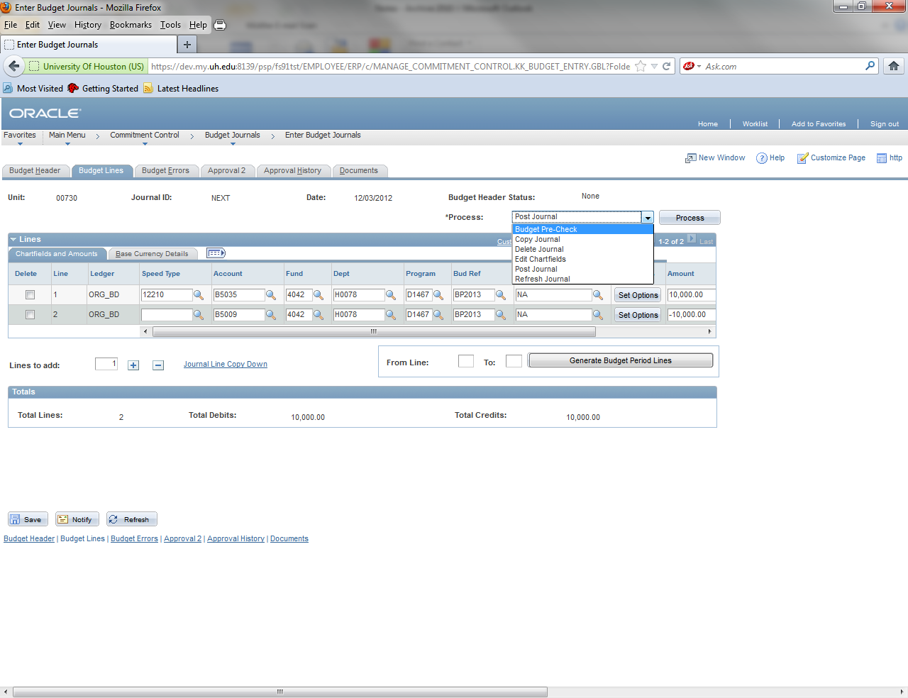

- If an incorrect cost center is entered, the “Budget Pre-Check” process recognizes the chartfield combo error and has an error message “Invalid Value”.
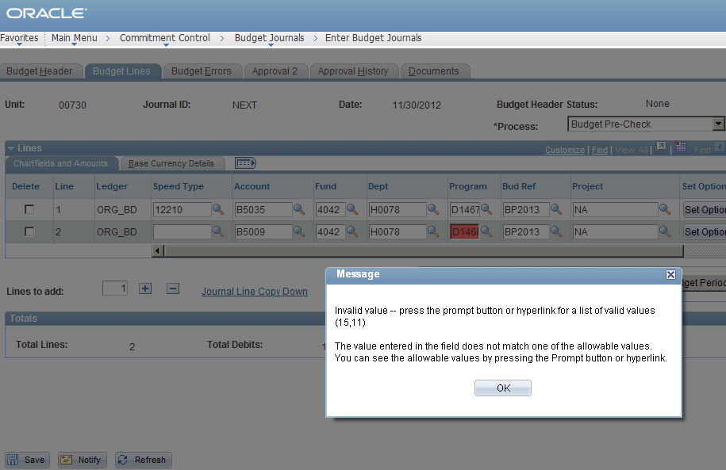

- Error message “Budget Checking Error Exist” appears when there is insufficient budget. Example below is when $10,000 was deducted from B5009 and the available amount is $4,422, the insufficient error message comes up. Please review 1074 Report. Repeat the “Budget Pre-Check” process once the correction has been made

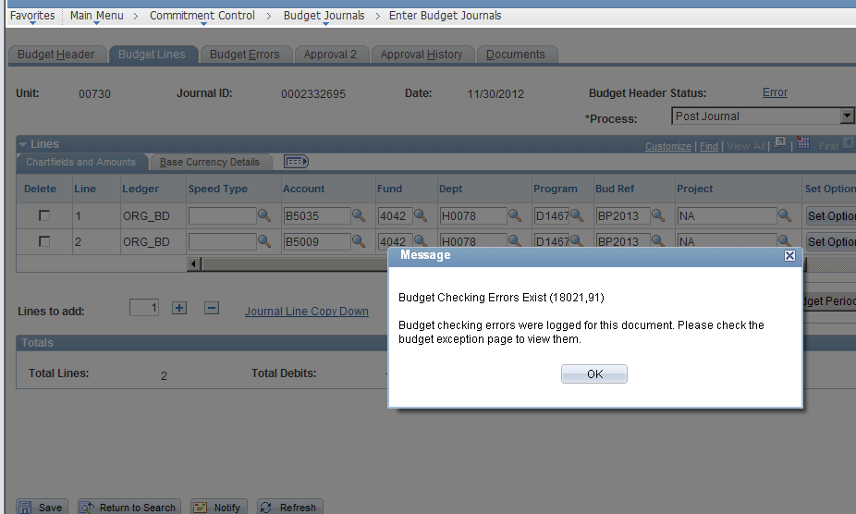

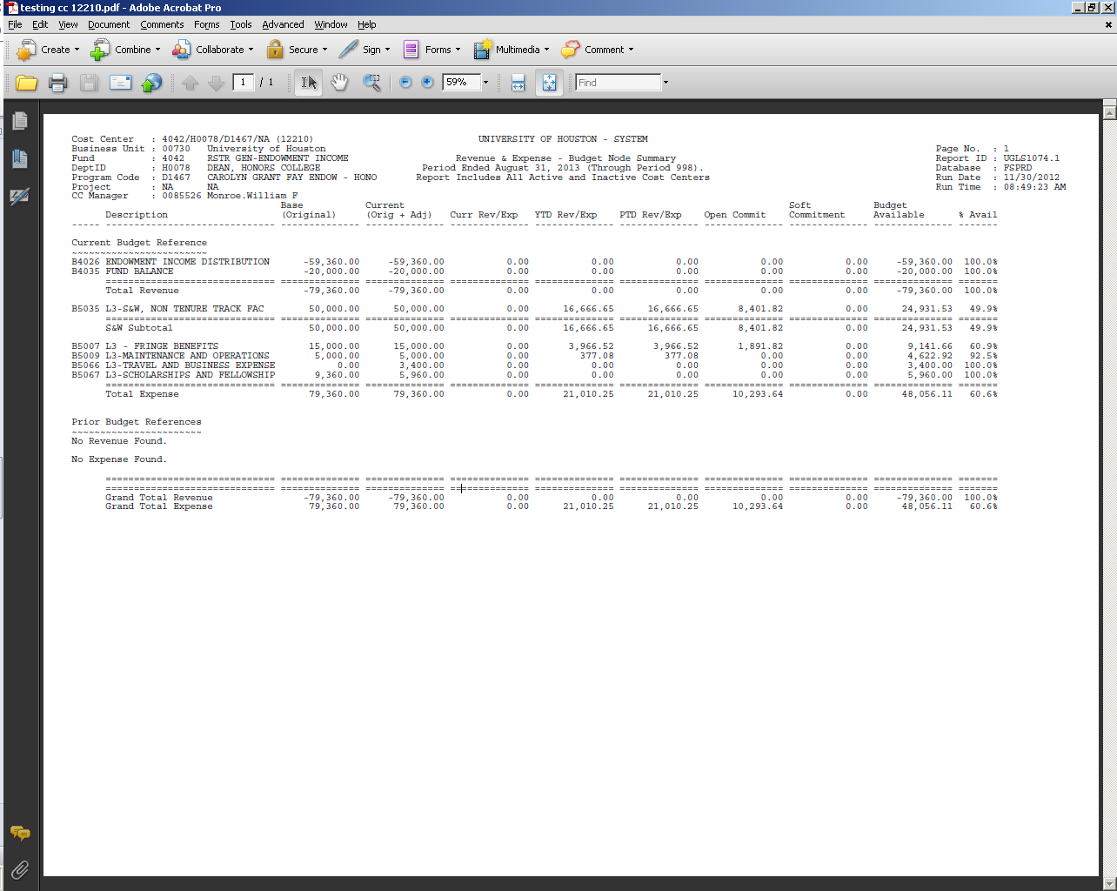

Save

- Select the appropriate tab on ‘Approval 2’ tab. Budget office chooses “Approve/deny/recycle” from the drop down menu and selects “Apply”.
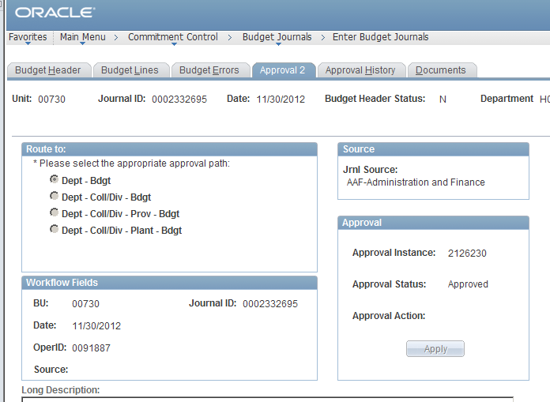

- Budget office will post the journal by selecting the “Post Journal” process. Click “Yes” on the box.

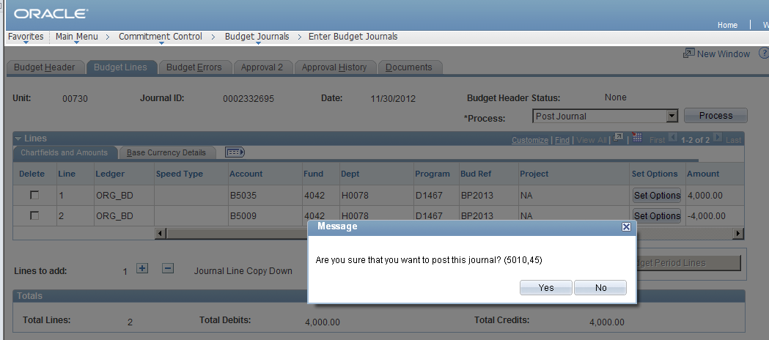

- The budget journal is then posted.

