Purpose: The Department Excel Report is an optional report that departments can run to see a list of P-Card or Travel Card transactions in an Excel format. The Department Excel Report may not be used as a substitute for the Expense Report, which must be printed and signed by the cardholder and certifying signatory each month.
- Log in to GCMS: https://www.globalmanagement.citidirect.com/sdng/login/login.do
- Click on Reports tab and select Schedule Reports
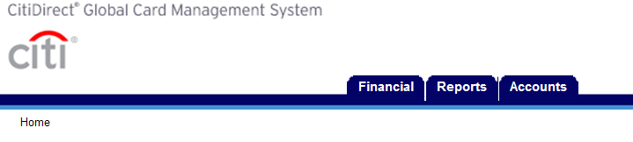
- Select DEPT_EXCEL REPORT
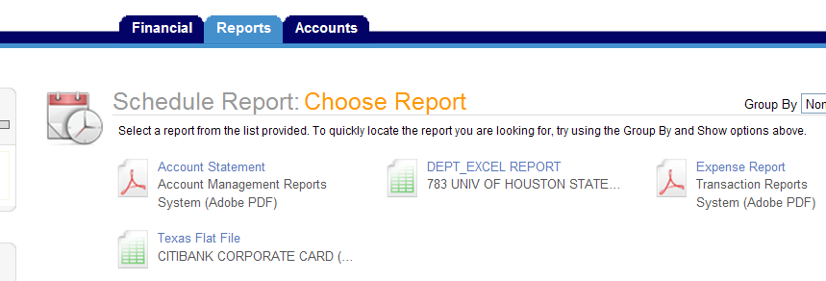

- Enter Account Name or Account Number and click on search.
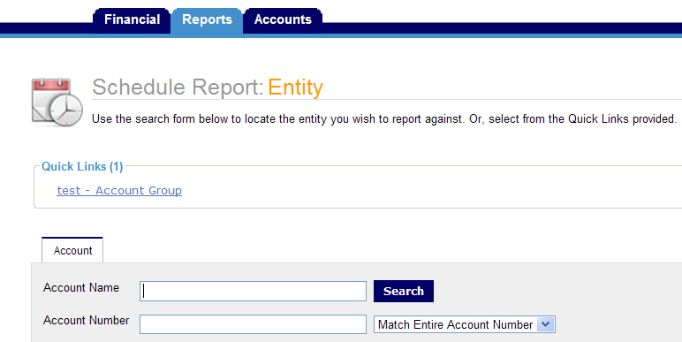
- Click on the P-Card or Travel Card Name
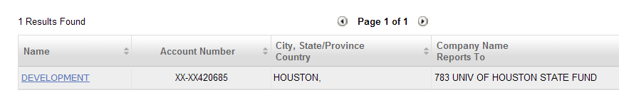
- Enter a Description and click on Next
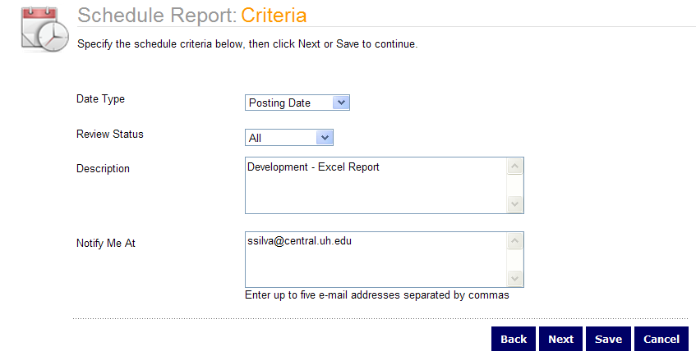

- Click on Reporting Cycle and select month and click on Save.
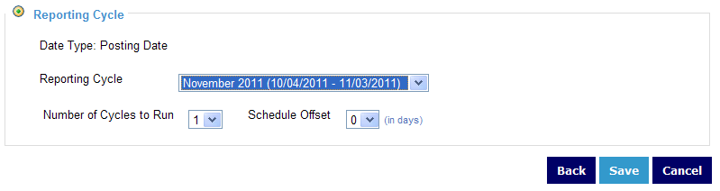
- Go to Inbox to pull up the completed DEPT_EXCEL REPORT.
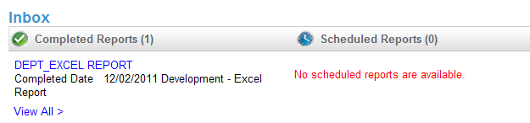

Questions: Contact Sandra Silva at 713-743-5883 or ssilva@central.uh.edu if you have any questions about running this report.

