Directions:
Charles F McElhinney Hall
4800 Calhoun
Houston, TX 77204-5009

McElhinney Hall

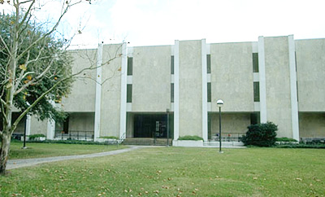
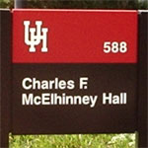

Directions to this building from I-45: (downtown)
- exit Cullen
- turn right on Cullen
- go through three traffic lights
- after UH Entrance 14, McElhinney will be the second building on the left
Directions to this building from 610 and 288 south:
- from 610 south - merge onto 288 North
- merge onto I – 45 South toward Galveston
- follow the above directions
- Parking: proceed to the Visitor Information Booth on Cullen Blvd: http://www.uh.edu/campus_map/buildings/INF2.php (near the Athletics/Alumni Facility); if you are coming from 45 (Gulf Freeway):
  - You will exit Cullen Blvd and travel Southbound, stay in the right lane
  - Landmark: UH Baseball field will be to your right at the corner of Elgin Street and Cullen Blvd
  - Visitors Information boot will be immediately pass the baseball field.
- Coming from 45, the Visitors Booth will be to your right before McElhinney Hall (McElhinney Hall will be to your left after the UH Entrance 14 light)
  - Inform the attendant you are schedule to attend NHO and you will be given a parking pass for the day and further instructions on where to park.

Visitors Booth Photo
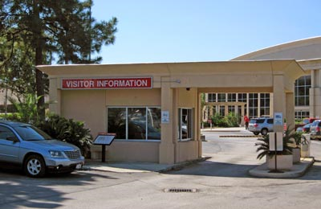

Where to park for the day:
- Once you exit the visitor’s booth, continue southbound on Cullen (stay in your right lane); at the first light (Holman St), make a right.
- Make a left into the first parking lot entrance (you will be in parking lot 15G).
- Your assigned parking lot will be: 15G (UH Robinson Stadium parking lot). However, you may park on either side/back of Robinson Stadium. Make sure you do not park in an area designated for Faculty/Staff parking, you may be ticketed (there will be signs stating Faculty/Staff parking only).
- You will be competing for parking spaces with our UH students, please be patience and allow yourself a little extra time to find parking.

Although University of Houston official mailing address is 4800 Calhoun, McElhinney Bldg. faces Cullen Blvd. If you MapQuest/Google: 4800 Cullen your directions may be more clearly defined.

